**Archery**

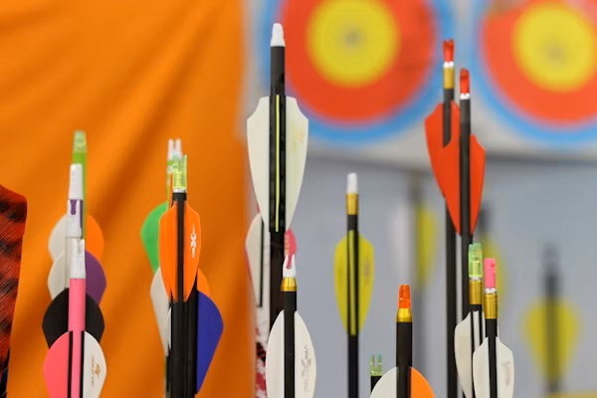

**Description:** A sport that involves shooting arrows with a bow at a target.

**How to Play:** Players take turns shooting arrows at a target to score points.

**Location:** Indoor/Outdoor

**Things Needed:** Bow, arrows, target

**Number of Players:** 1 or more